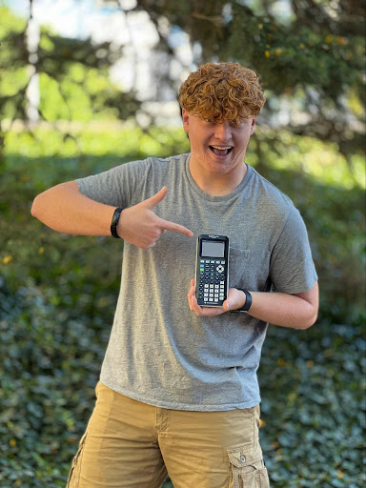

**Solar Car Challenge TI-84 Plus CE Python Calculator**

Using the new TI-84 Plus CE Python calculator, demonstrate how it can be used in the design, engineering, production, and racing of your high school solar car.

**General Instructions**

(1) Your use of the TI-84 Plus CE Python calculator within the Solar Car Challenge Project must be set-out in a detailed, written plan explaining specifically how you are using the calculator.

(2) We are not asking you to present a “plan for use.” We want to see the actual use of the calculator within your current solar car design, engineering, production, and racing.

(3) Your written plan must be supported by photos, videos, or power point presentations.

(4) Your plan must be accompanied by a video of at least one team member explaining your plan, and using photos of your solar car to demonstrate that plan.

(5) Teams will not be supplied with TI-84 Plus CE Python calculators.

**Submitting Plan**

(1) Your plan must be received in the Solar Car Challenge Office no later than midnight January 8, 2022.

(2) The written portion of your plan must be sent to:

Solar Car Challenge Foundation, 3505 Cassidy Drive, Plano, TX 75023

(3) The accompanying video must be sent in an mp4 format to

[video@solarcarchallenge.org](mailto:video@solarcarchallenge.org)

**Judging**

Preliminary judging will be done by the Solar Car Challenge Foundation. The top three entries will be submitted to Texas Instruments TI-84 Plus CE Python Engineers for their review.

The top three entries will be required to have one team member join a ZOOM meeting with TI Engineers and Solar Car Challenge Staff. This ZOOM meeting will give the teams a chance to better explain their project, and for all parties to ask questions.

Judges will give greater weight to plans that demonstrate multiple uses for the TI-84 calculator within their solar car project.

**Prize**

The winner of the competition will be announced at the January Solar Car Challenge Workshop on Saturday, January 15th at the DFW Marriott Hotel & Golf Club. The winner will receive a check for $1,500. The top three entries will receive crystal trophies.

**Questions**

Questions regarding this competition should be addressed to Dr. Lehman Marks at [marks@solarcarchallenge.org](mailto:marks@solarcarchallenge.org)